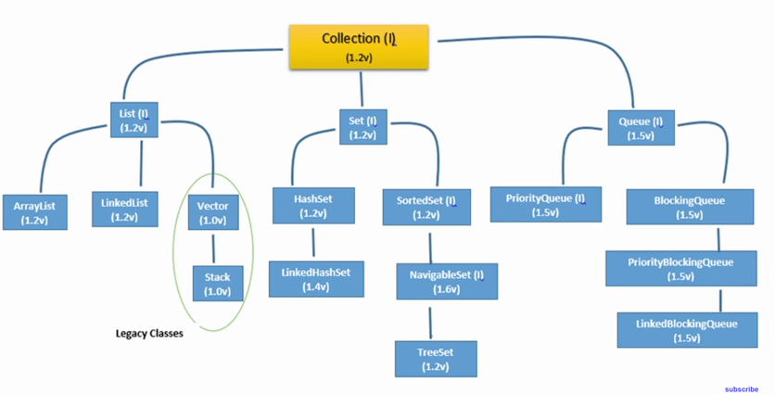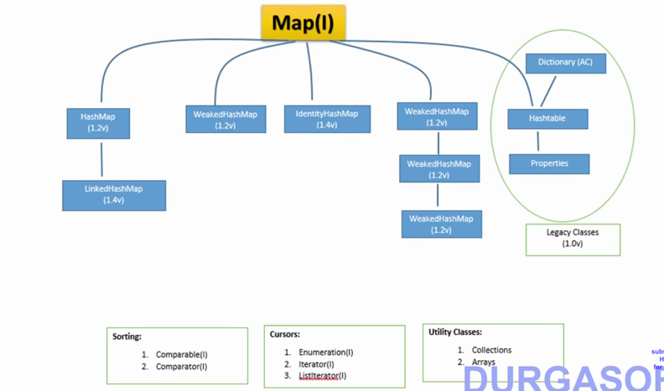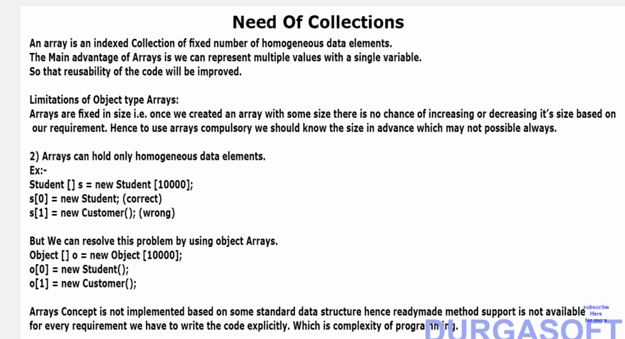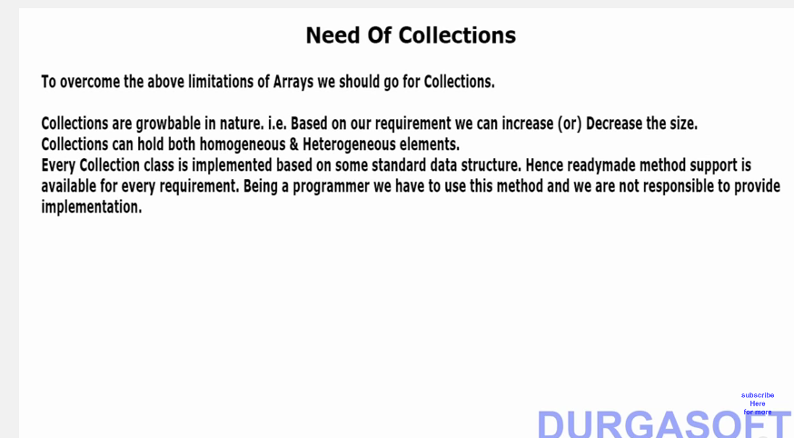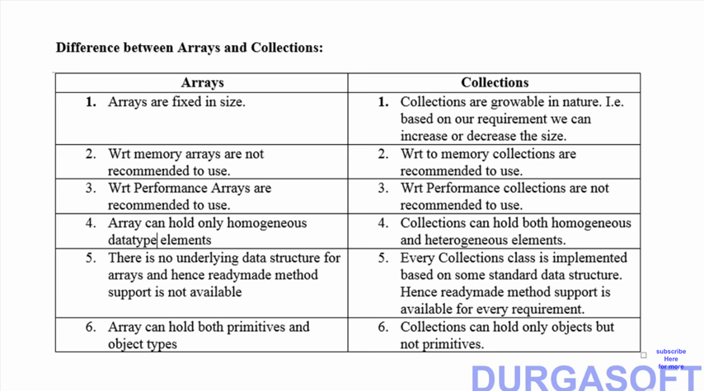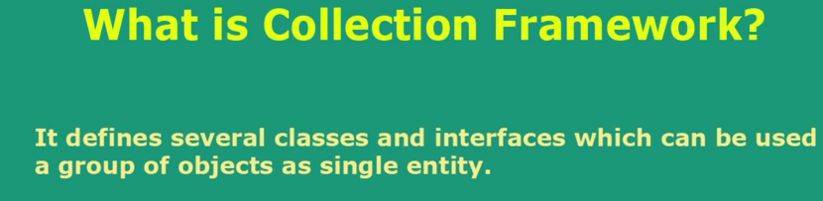

**Difference of Collection Framework in Java and C++**

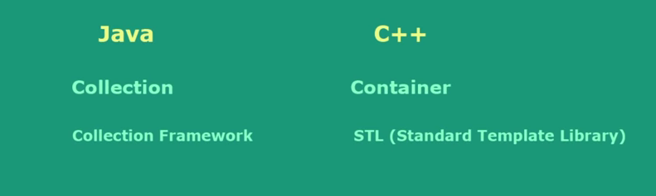

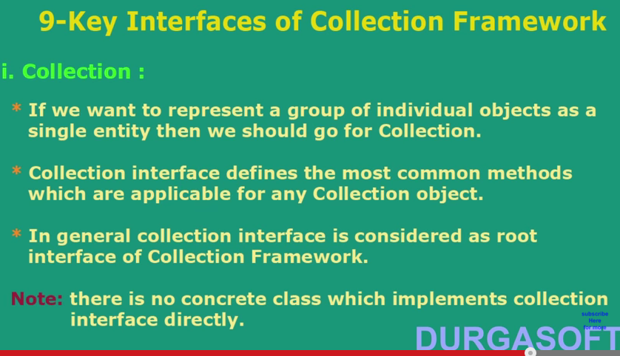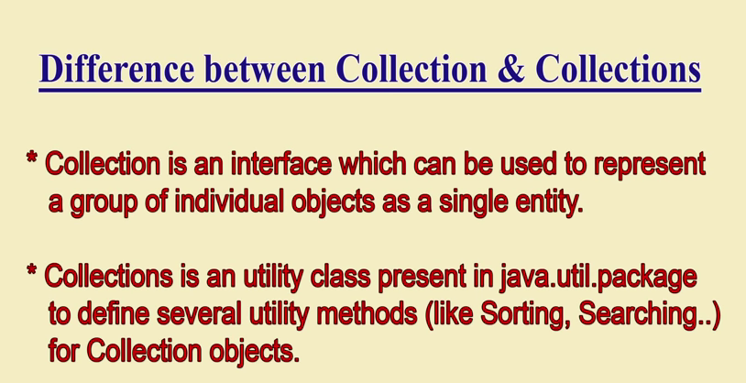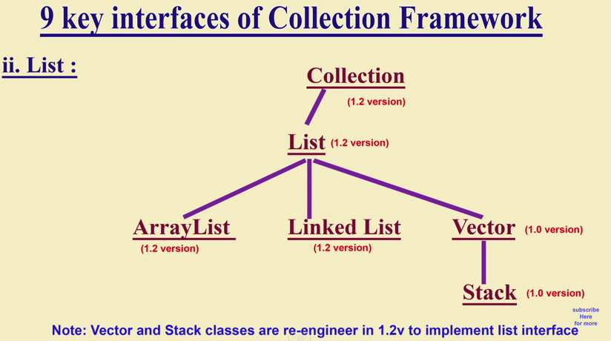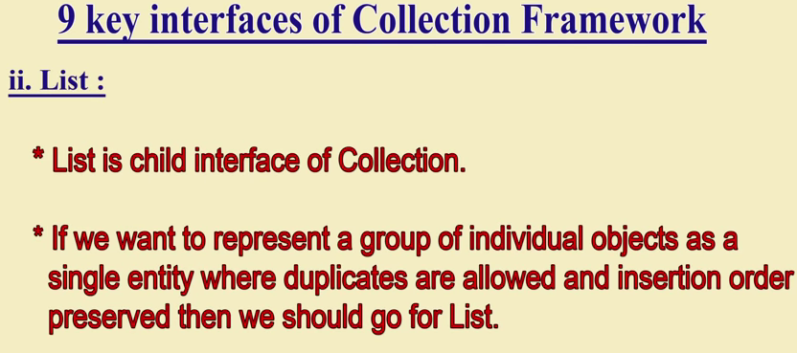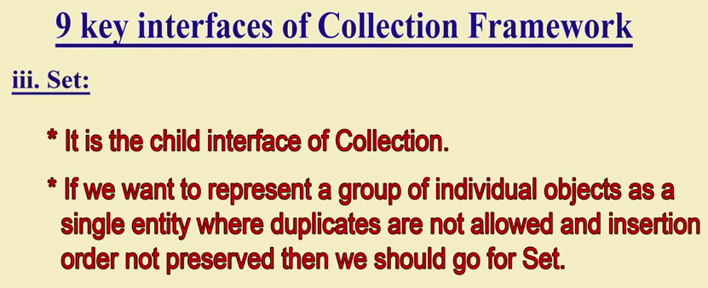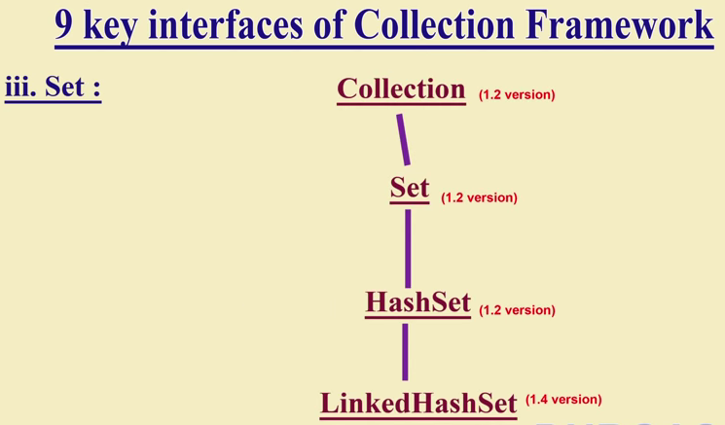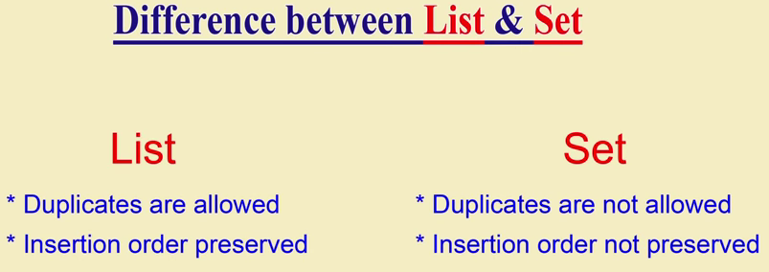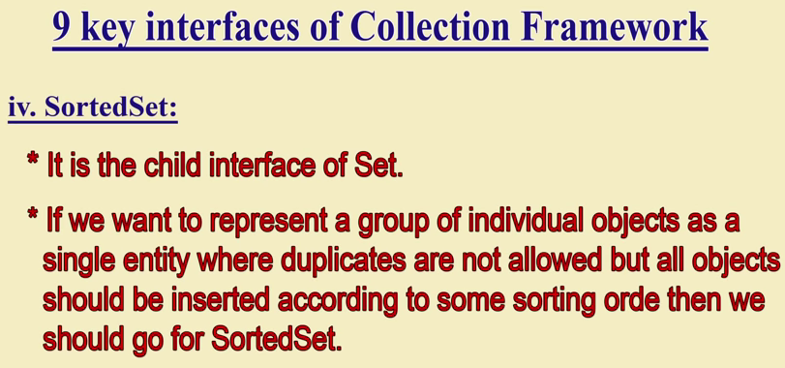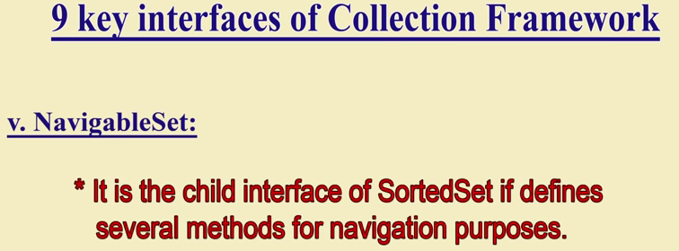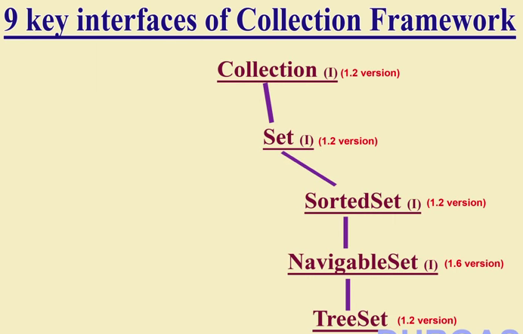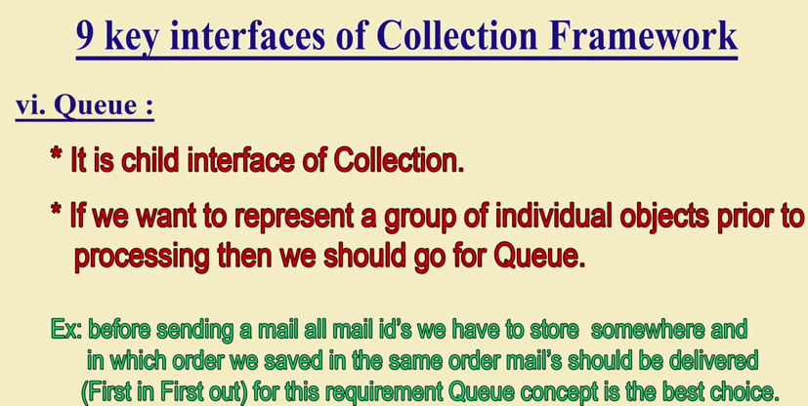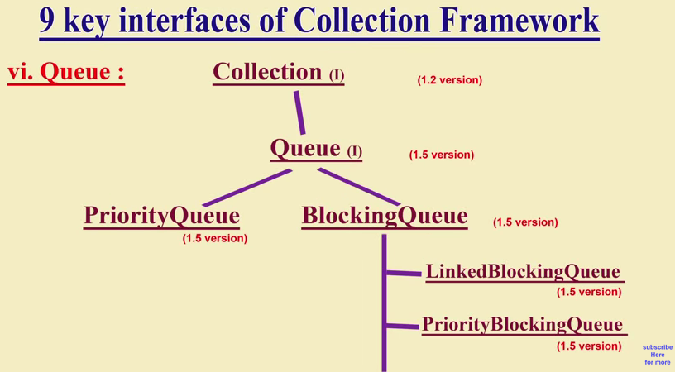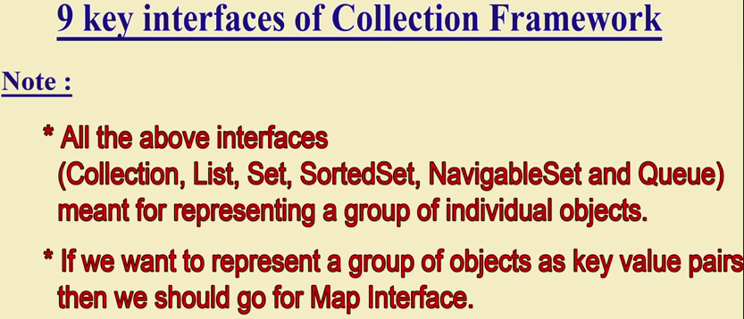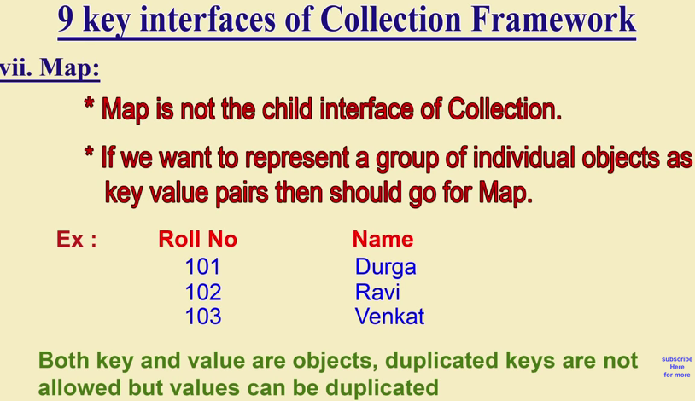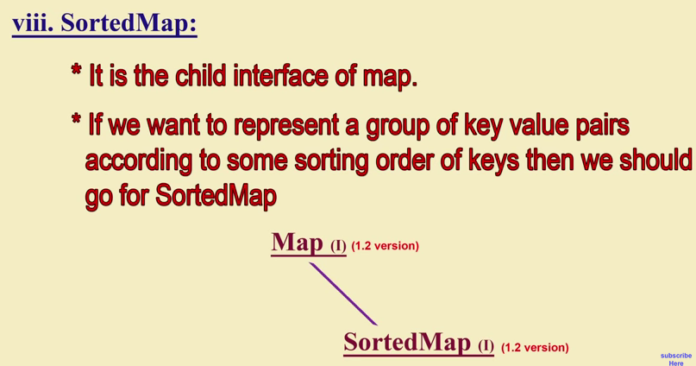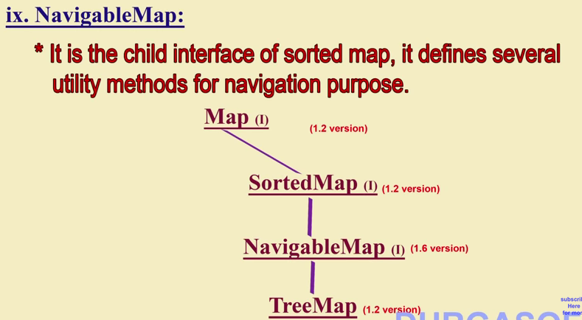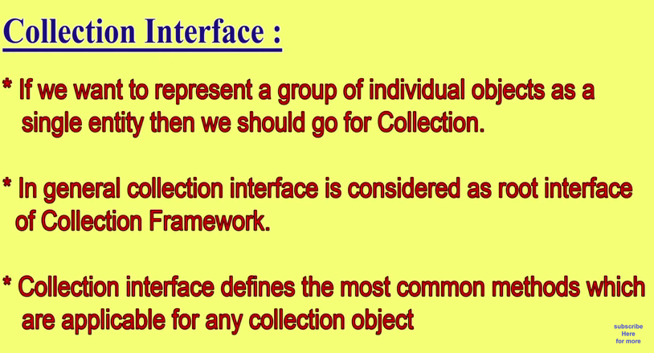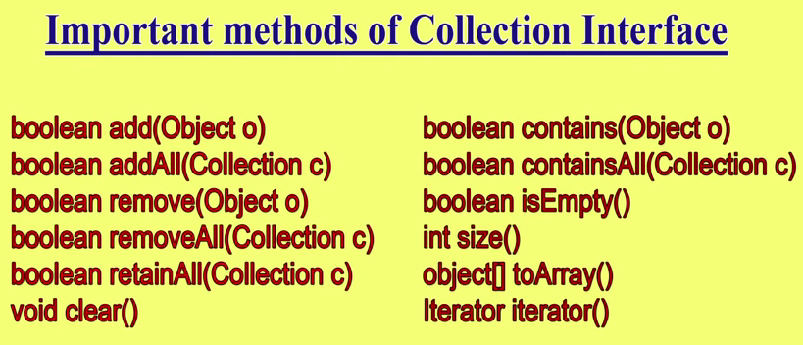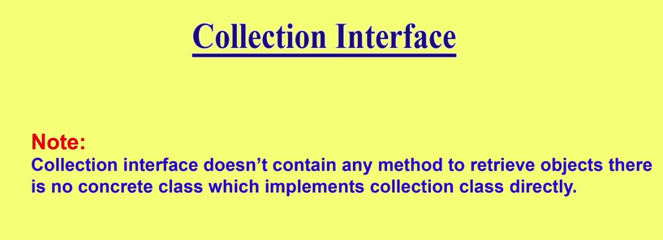

**---Detail of Collection -----------------------------------------------------------**

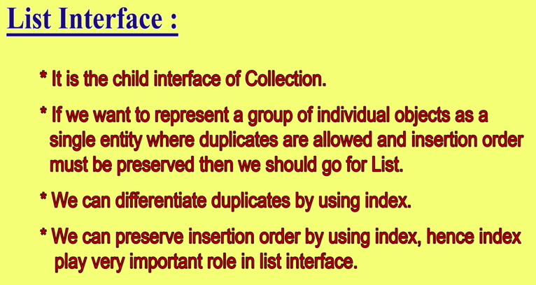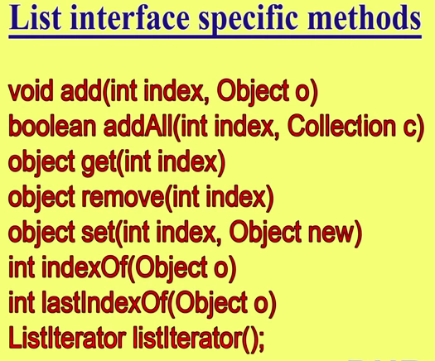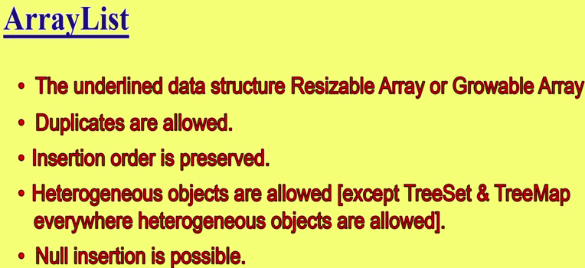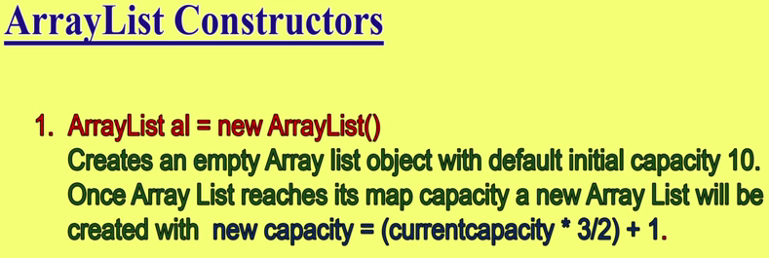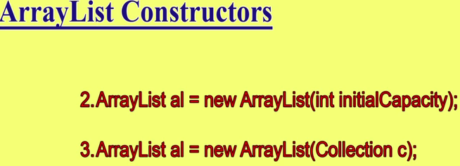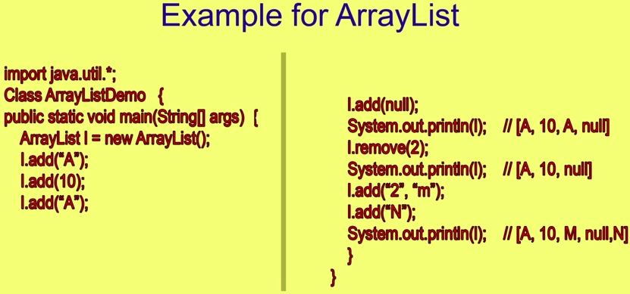

By default every collection Interface or Class extends **Serializable Interface and Cloneable Interface**. When a group of object are transferred from one place to another then after reaching to destination it creates a clone of the group of object and then start operation on that cloned object hence it extends Cloneable interface .

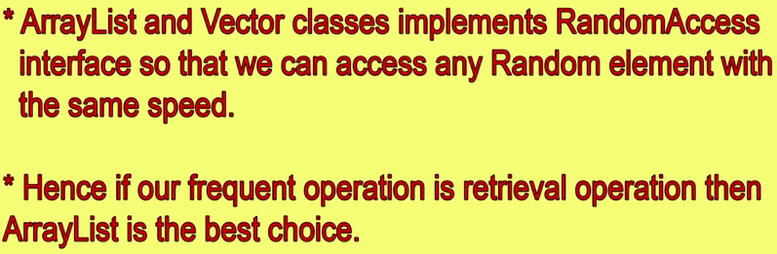

**Note:- Only ArrayLIst and Vector classes implements RandomAccess Interface for getting random element with the same speed . Hence whether we access first or last element it will take same time . And one more thing is RandomAccess Interface is a Marker Interface it does not contain any method.**

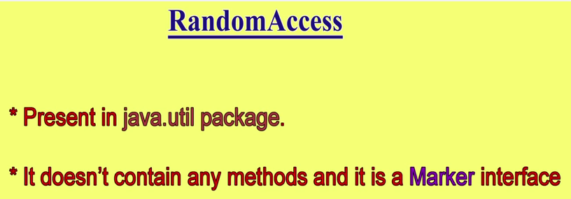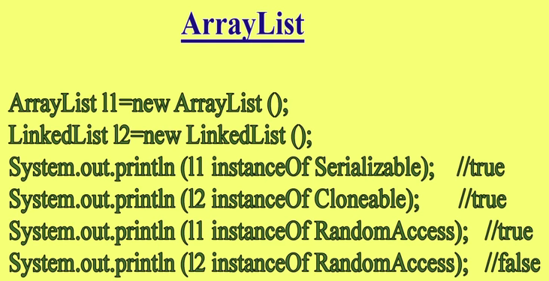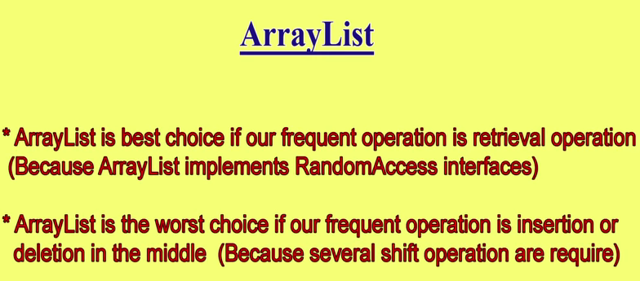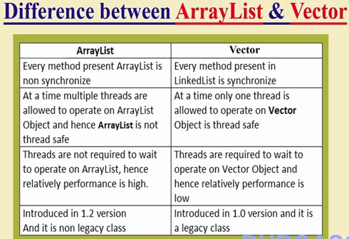

**ArrayList al = new ArrayList(); // Non Synchronized ArrayList:**

**To Make it synchronized :**

**List list = Collections.synchronizedList(new ArrayList()); // Here list is now synchronized.**

Note: **synchronizedList()**method is static and it returns list.

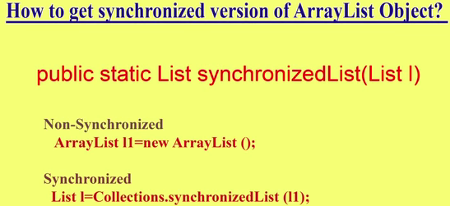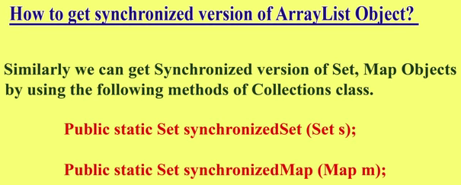

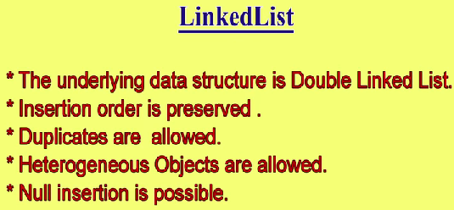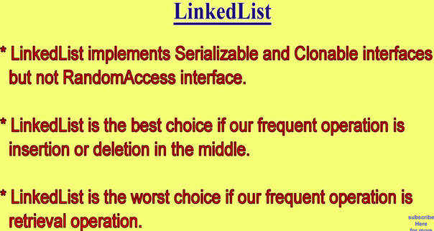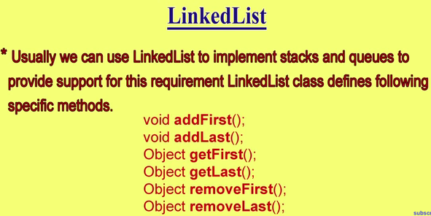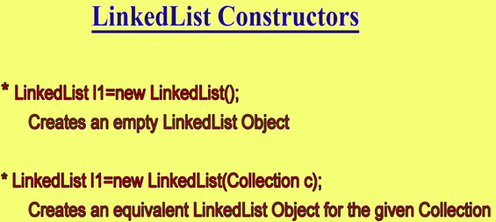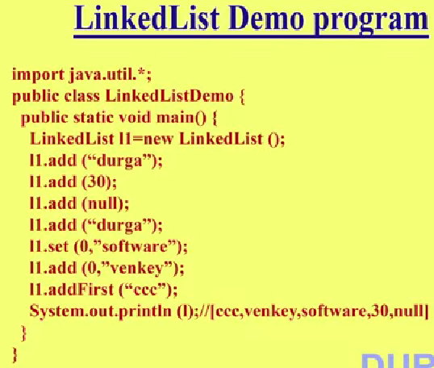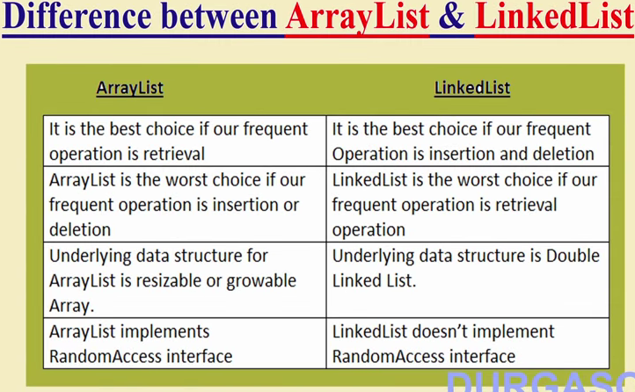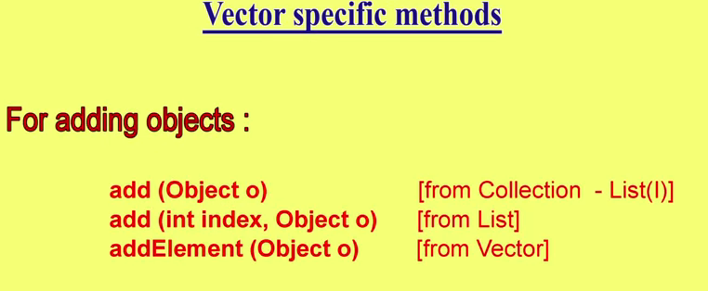

Note : Vector (V 1.0) is a legacy class of the collection frame work that is why all the method name is bit lengthy compare to ArrayList (V 1.2). Difference has shown in the above 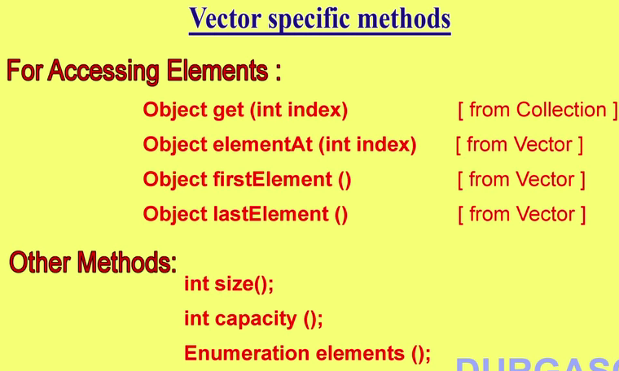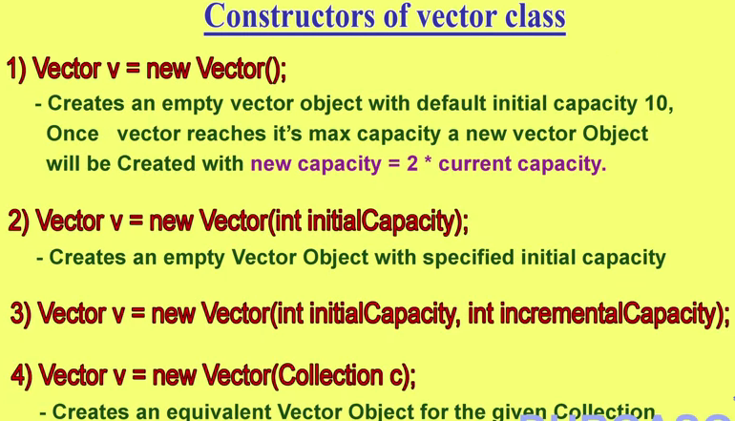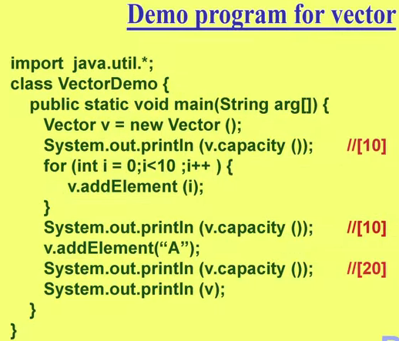

Since the capacity of V is increased by double , that is why after adding (A) the capacity Is increased by double (10*2= 20) .



**Note:- Only One empty element Constructor is present Stack s = new Stack()**;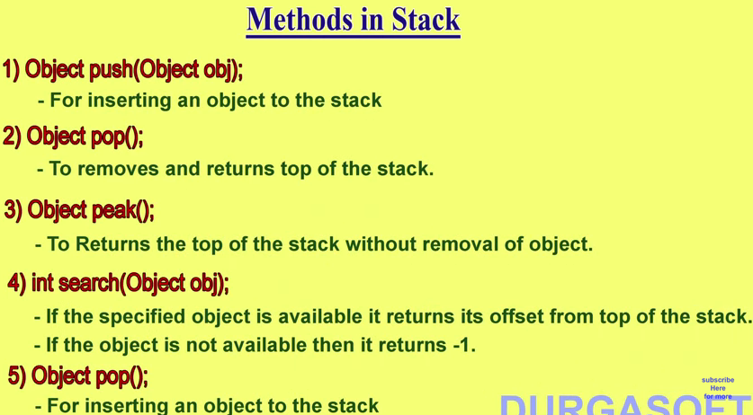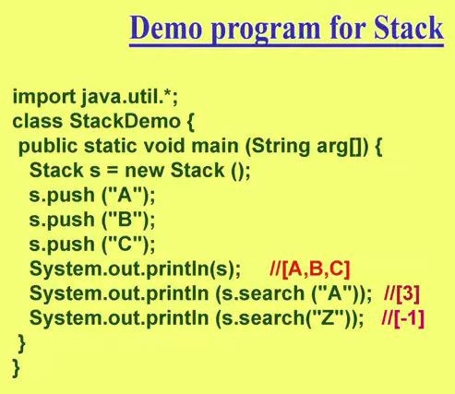**BecauseStack extends the class vector and vector preserves the order , so it would print the element in the same as they are entered. [A,B,C]**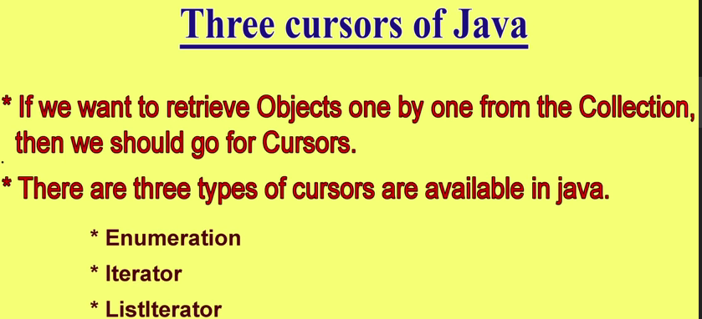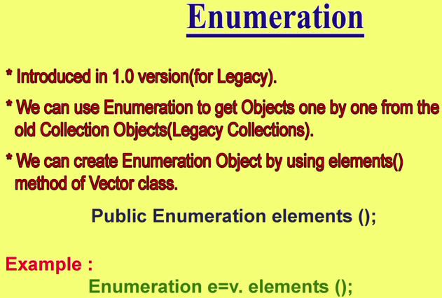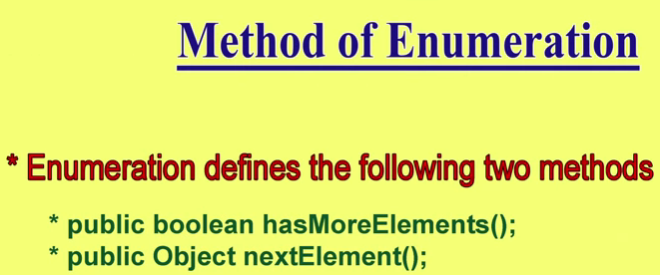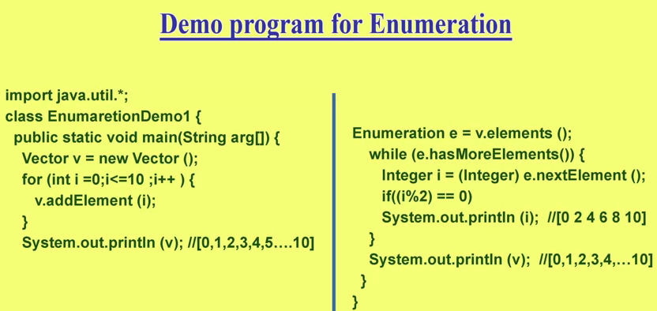

So Enumeration used for Vector class object/element iteration ,because Enumeration can iterate the object one by one 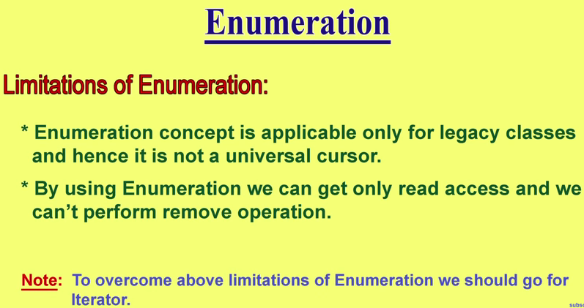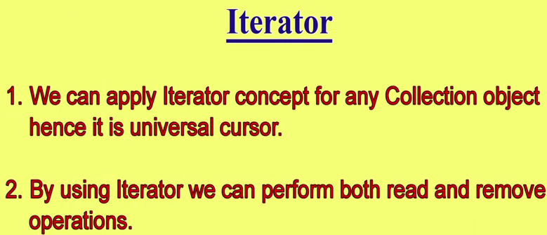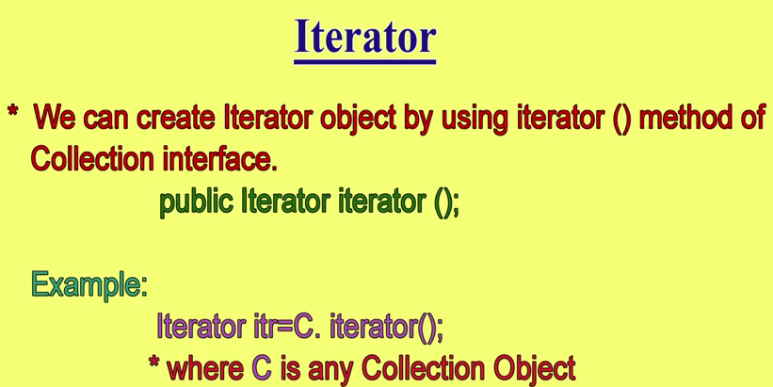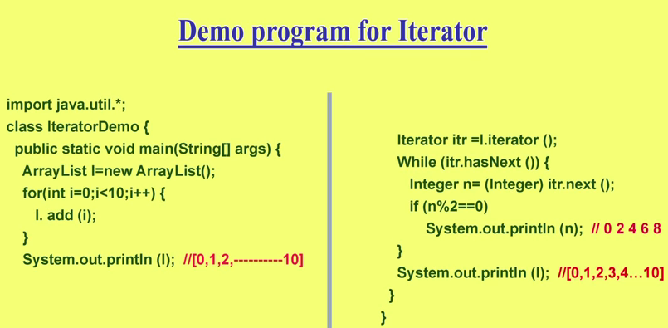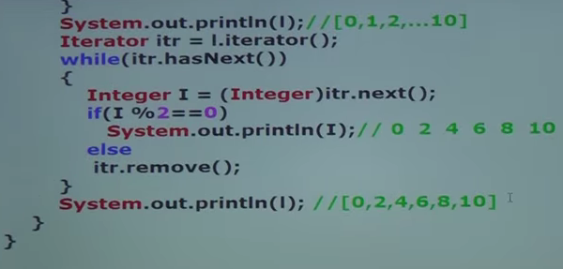

So One more method in Iterator Class is to remove element as we can see in the above example. Here it is removing all odd elements from the list and finally we get only even number of list.

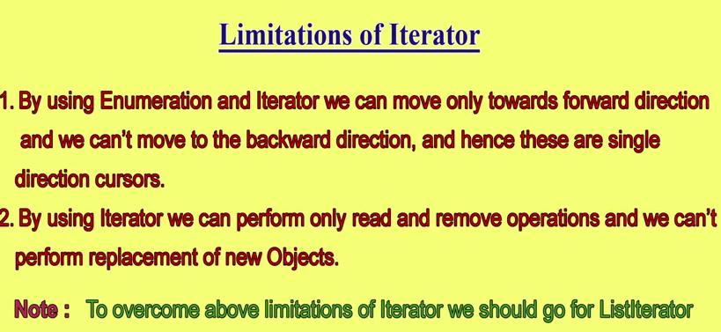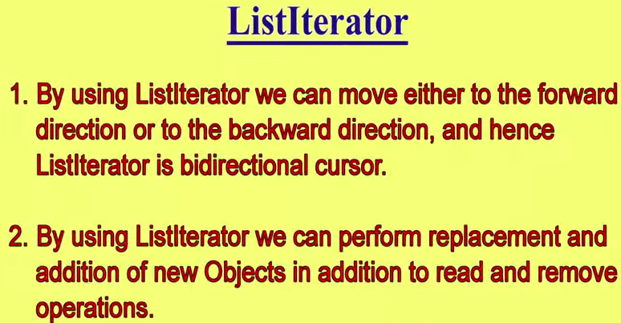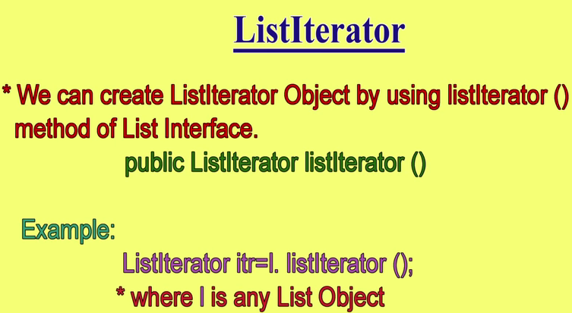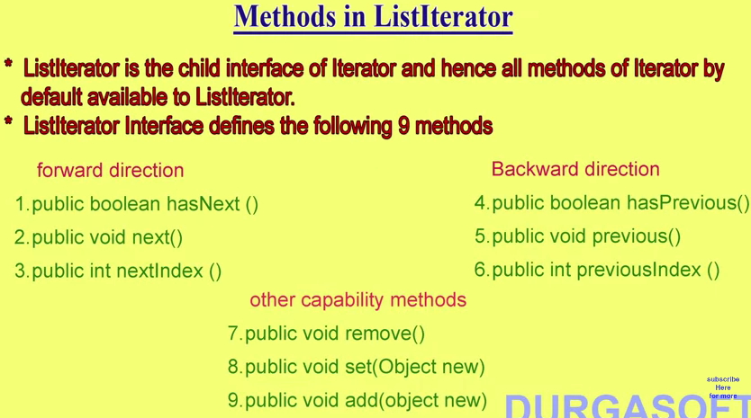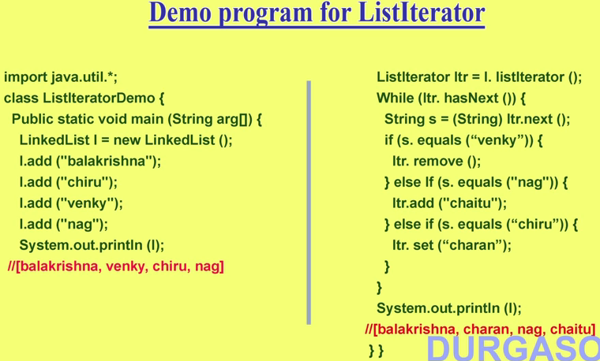

So Using ListIterator Interface cursor we can perform not only read but also remove , add , replace(set) also as shown in RHS of above screen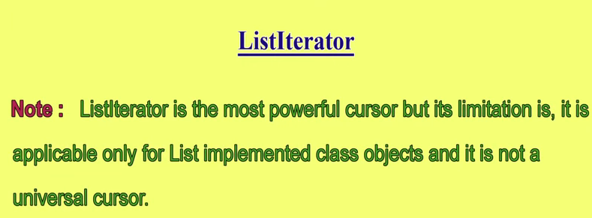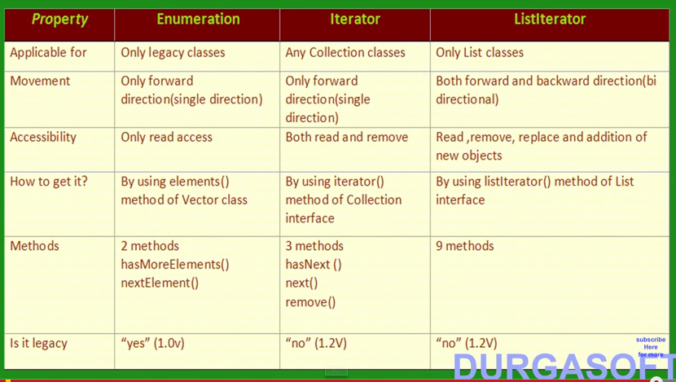

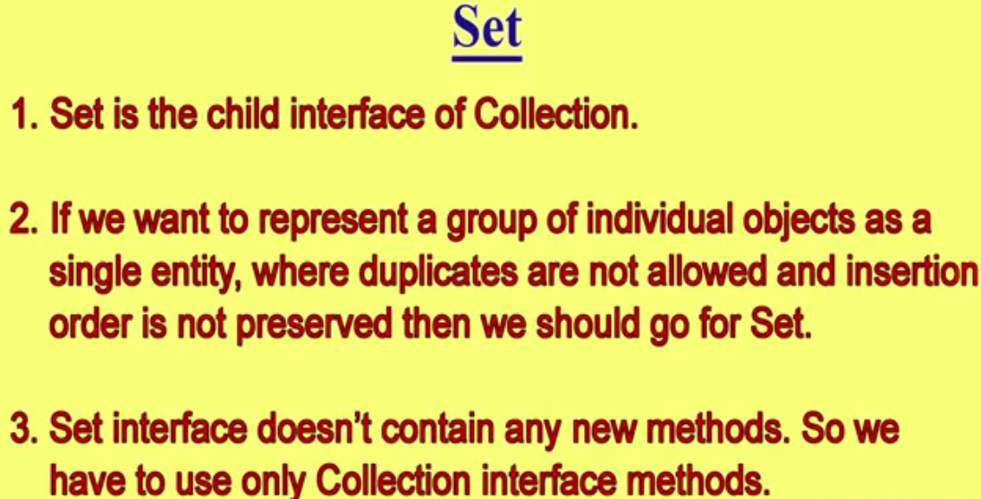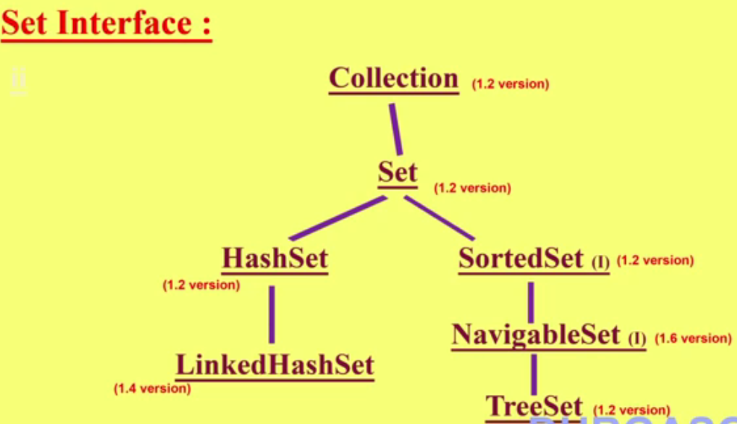

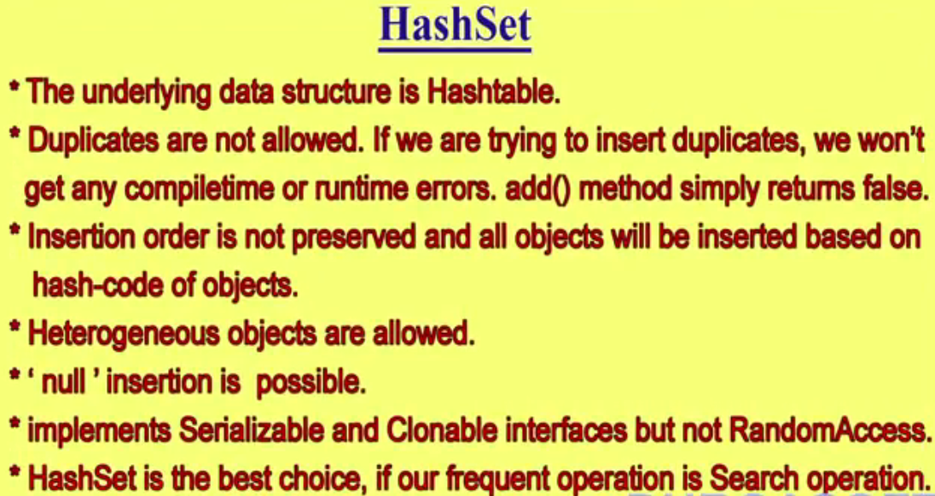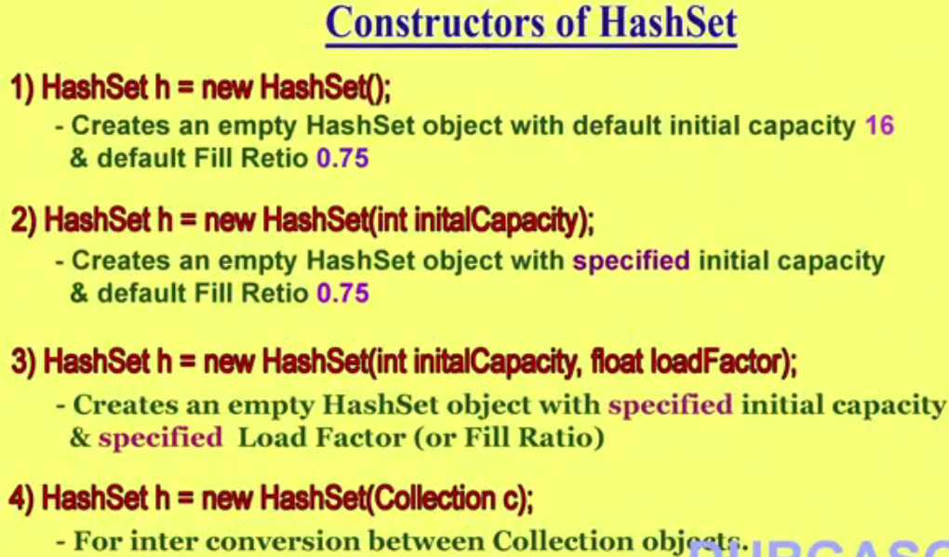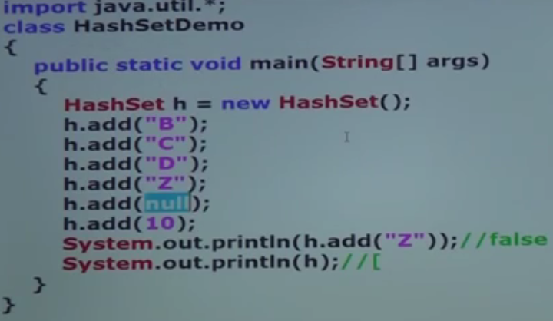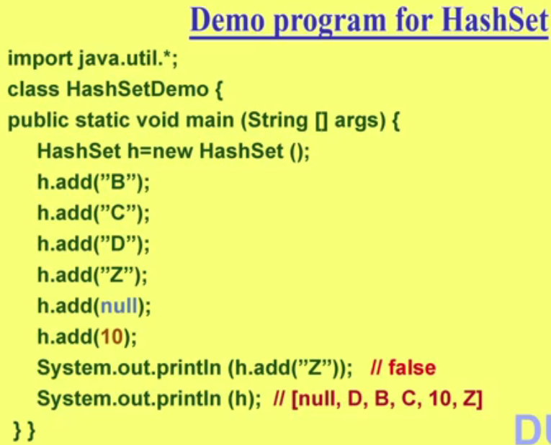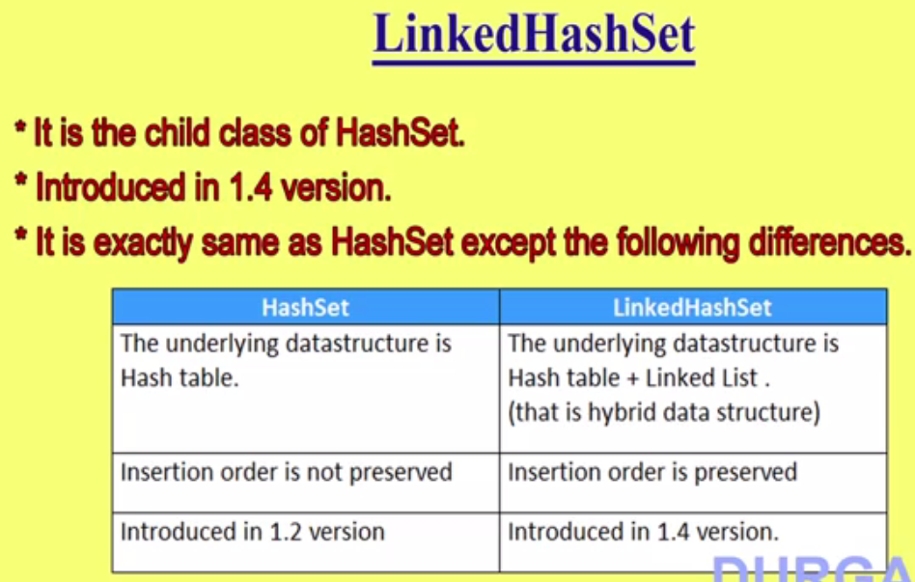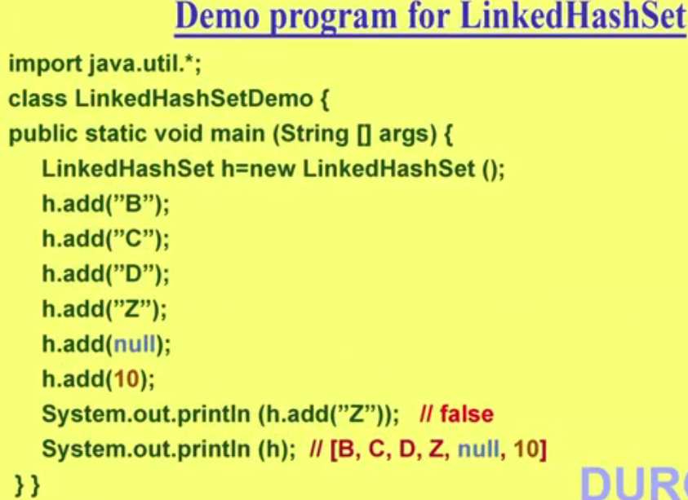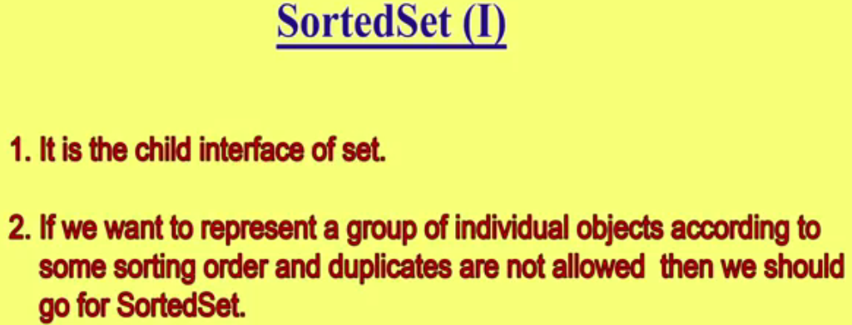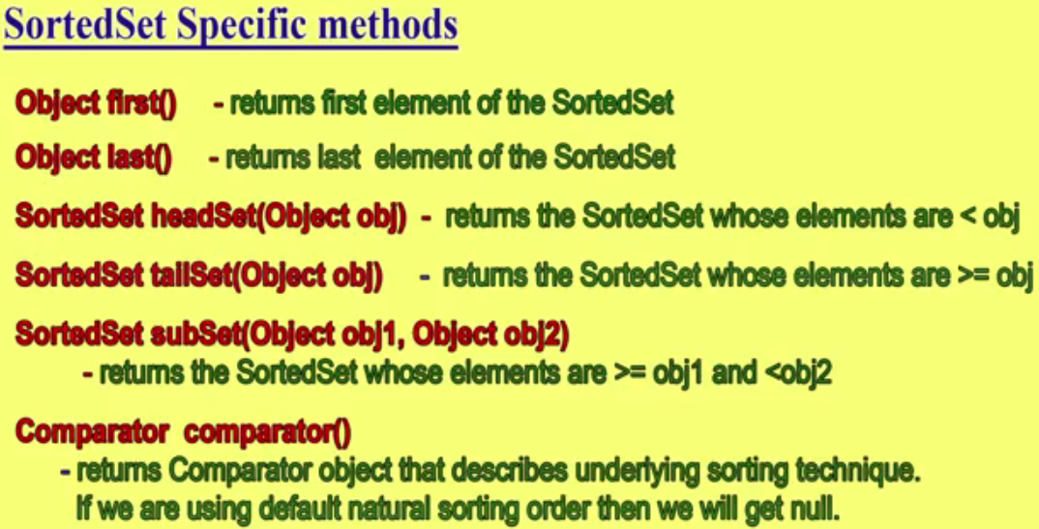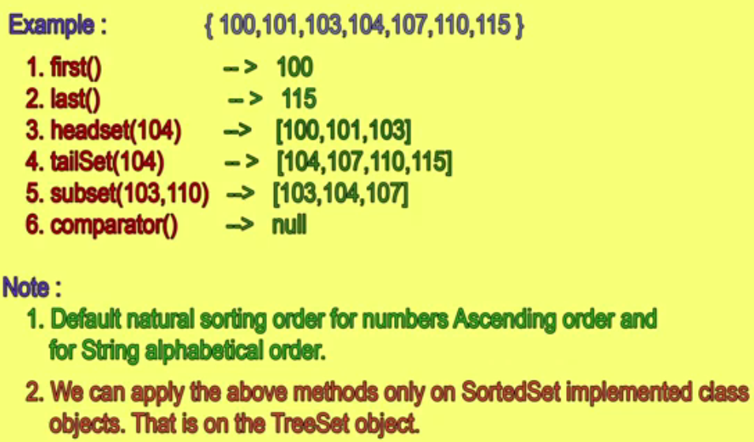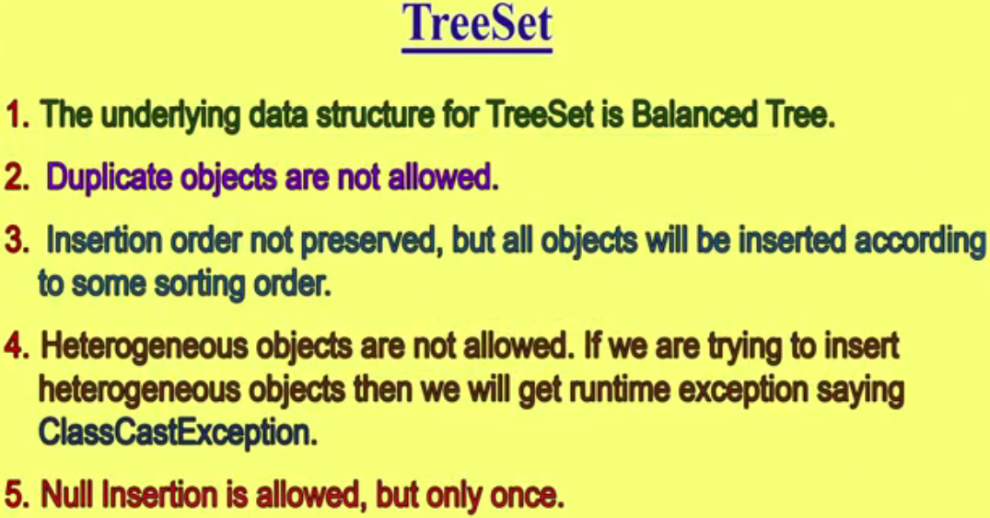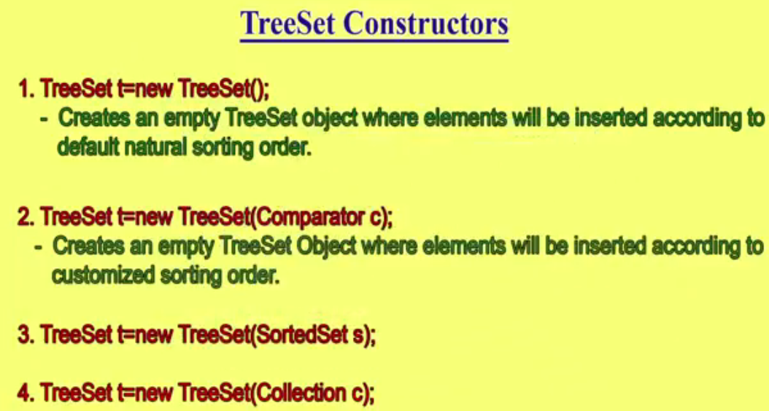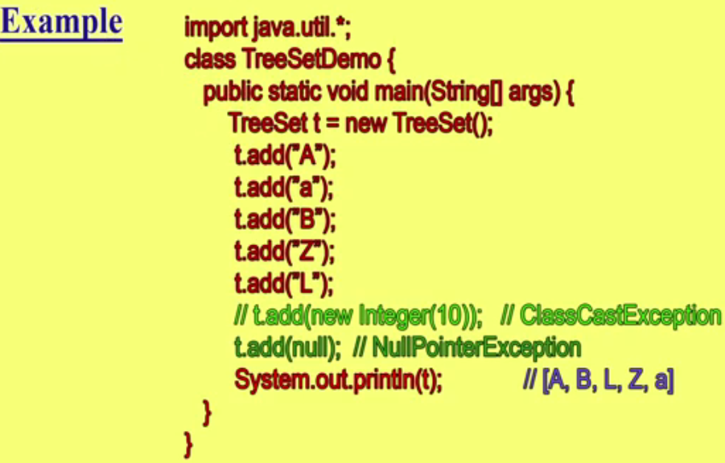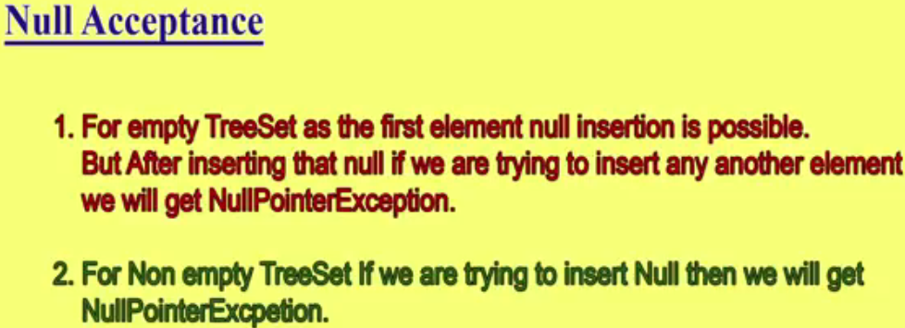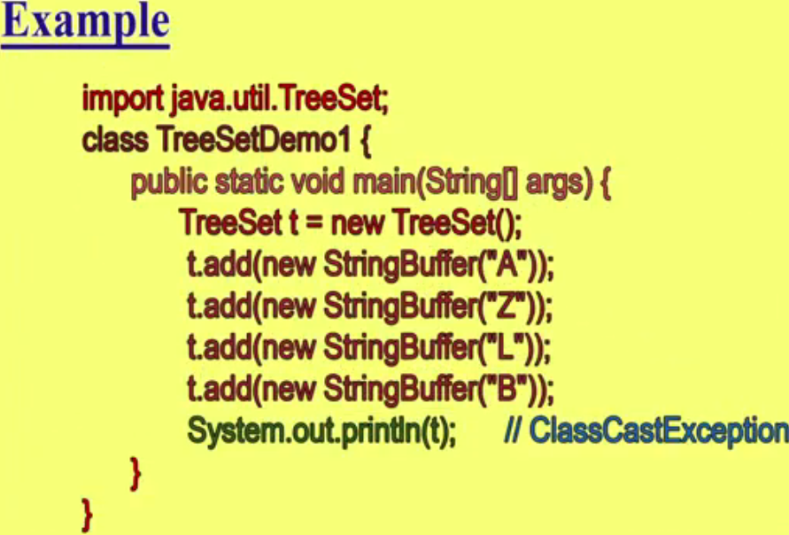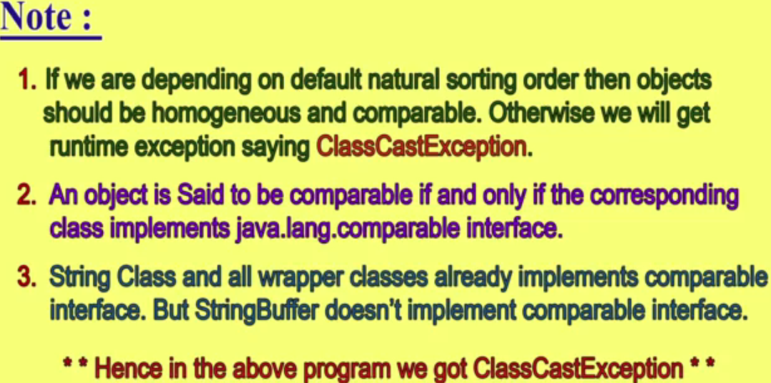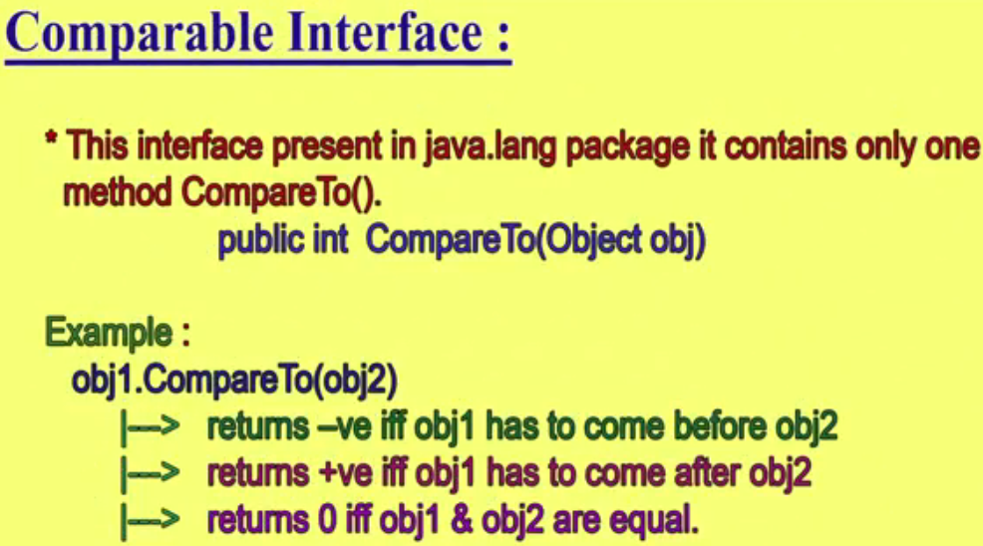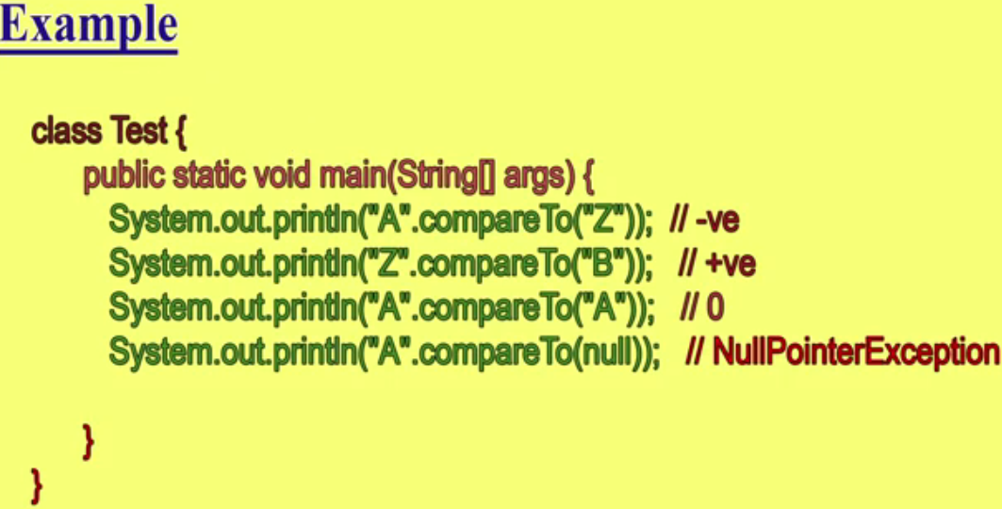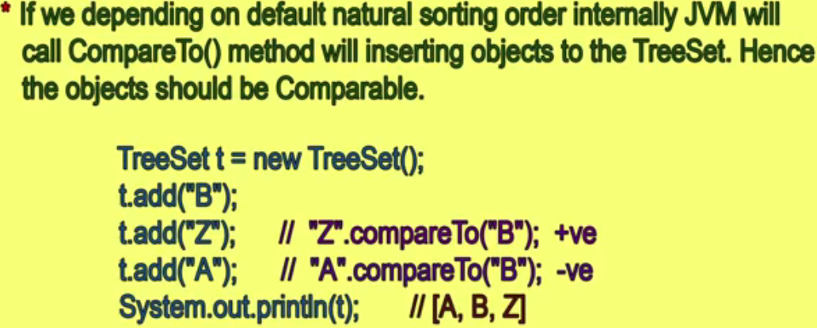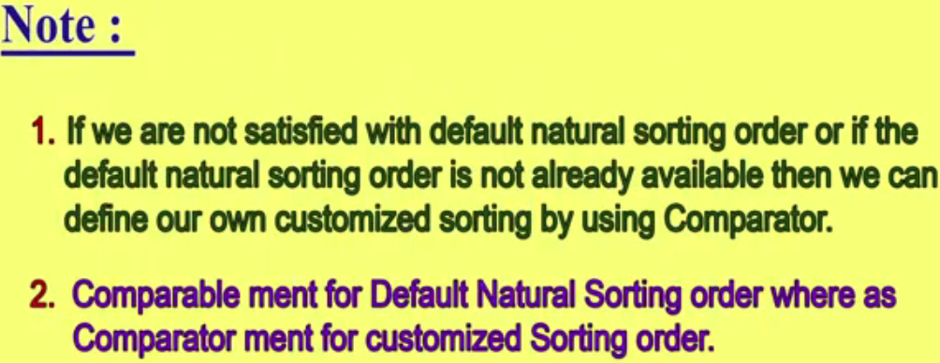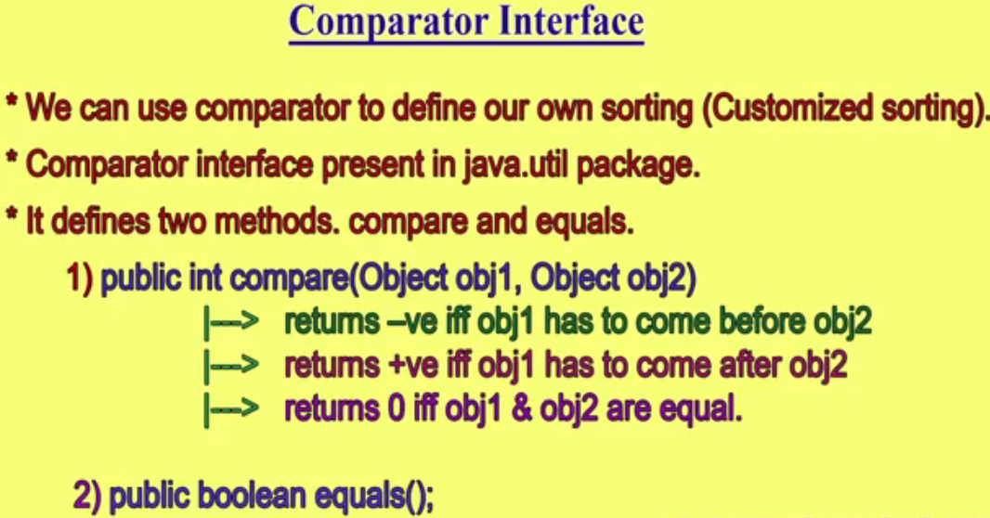

Tree Set Part 5 Onwards

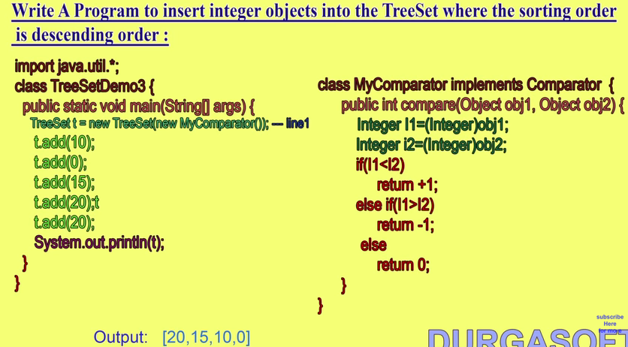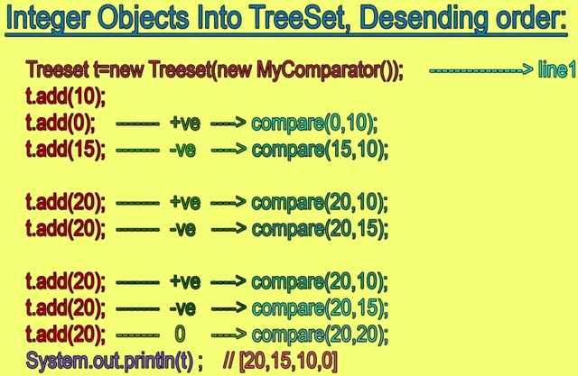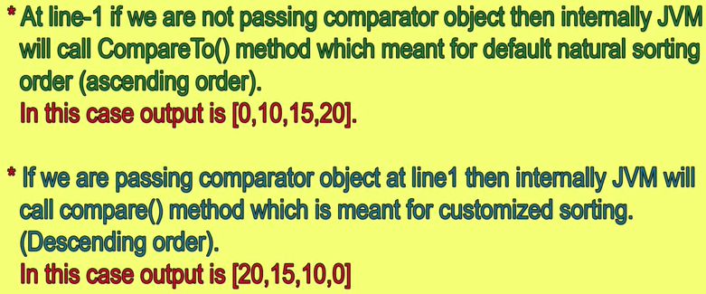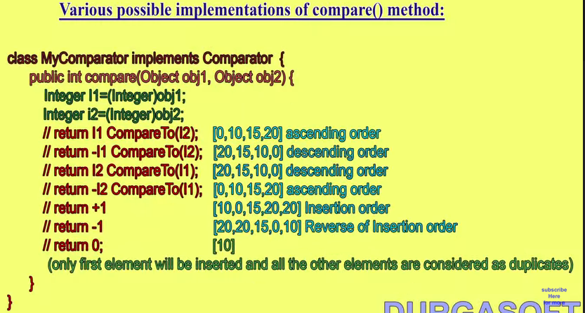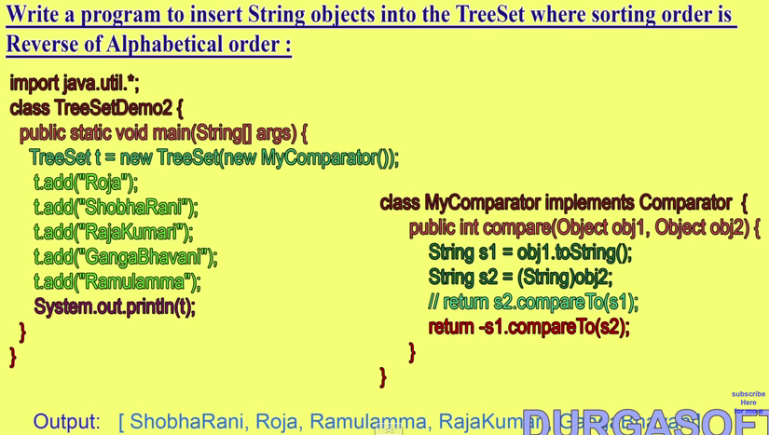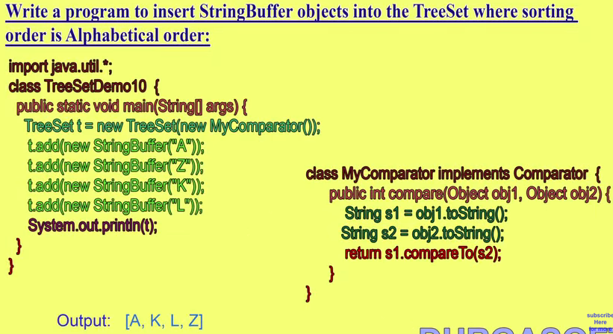

Note : In case of StringButter object if try to sort it then will get class cast exeption because StringButter class does not implements Comparable Interface .So to sort StringBuffer object we need to Comparator object and convert the String butter object into String using toString() method of String class. 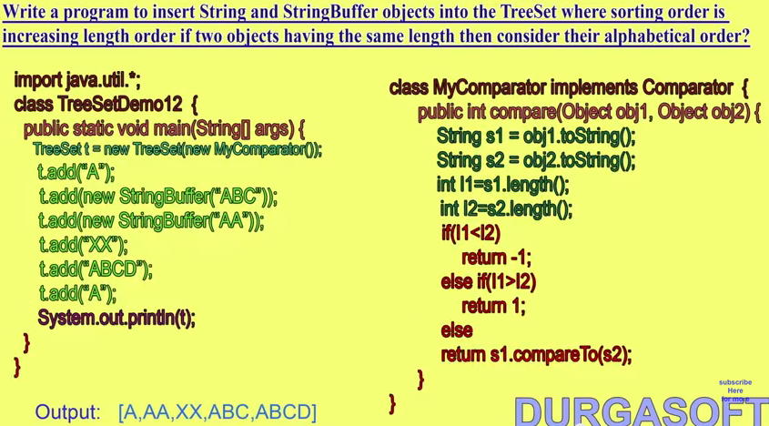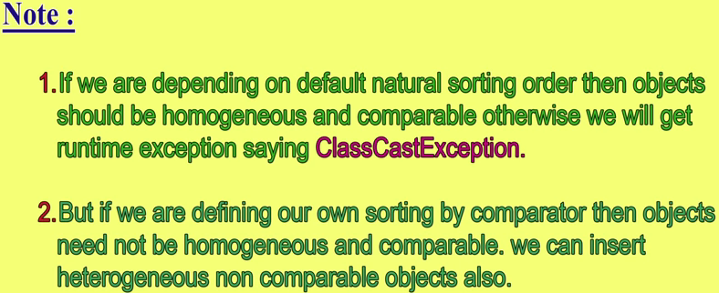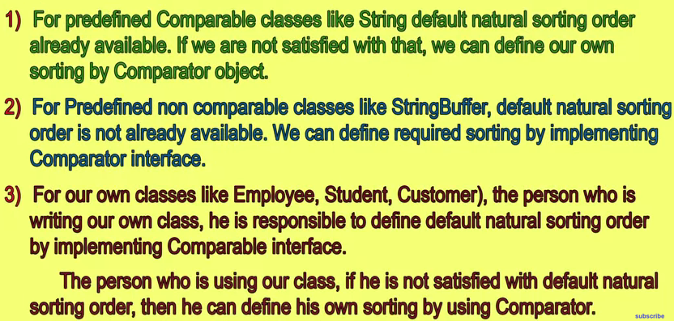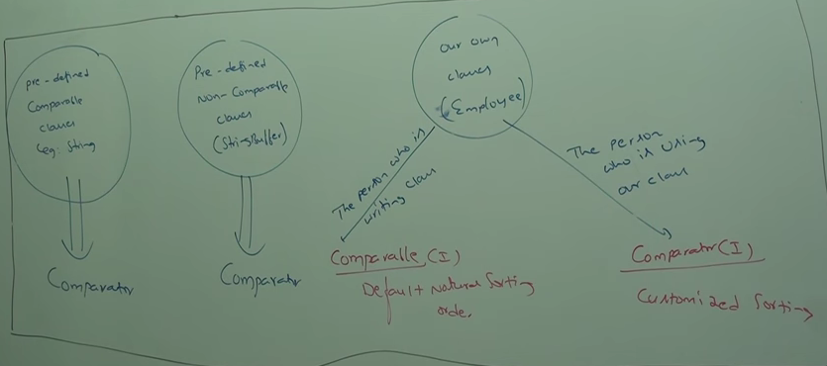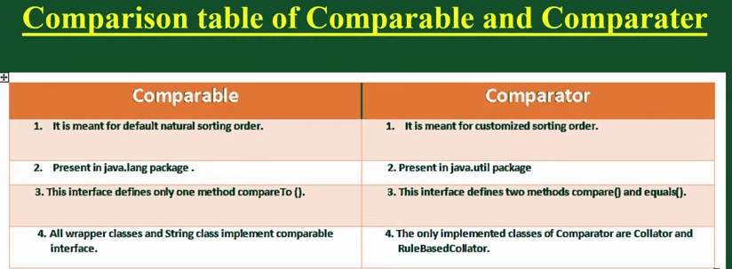

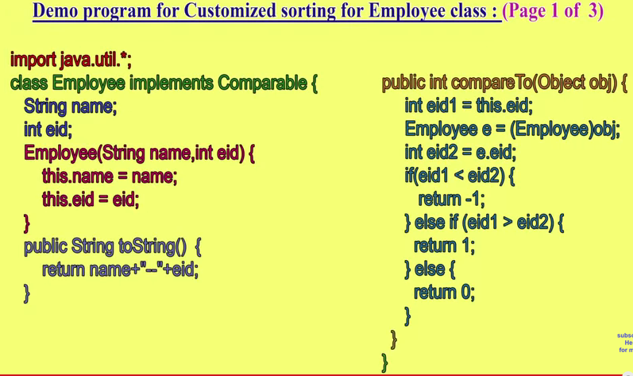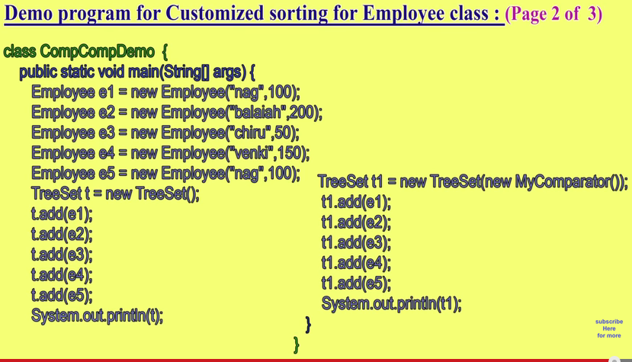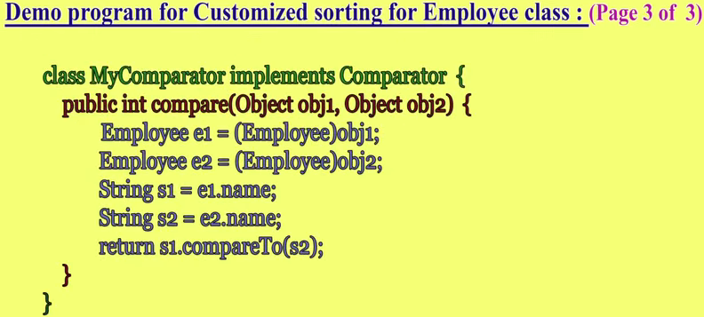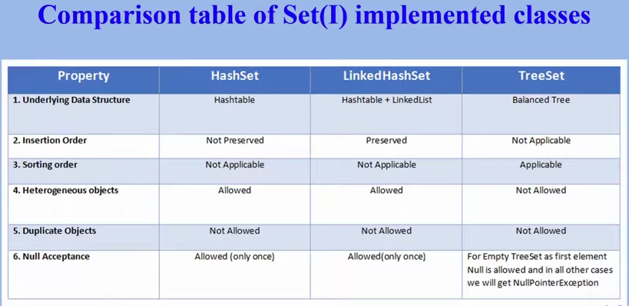

**HashMap vs. TreeMap vs. HashTable vs. LinkedHashMap**

Map is an important data structure. In this article, let's play with dogs and see how maps can be helpful in our development.  

### **1. Map Overview**

There are 4 commonly used  implementations of Map in Java SE - HashMap, TreeMap, Hashtable and LinkedHashMap. If we use one sentence to describe each implementation, it would be the following:

* HashMap is implemented as a hash table, and there is no ordering on keys or values.
* TreeMap is implemented based on red-black tree structure, and it is ordered by the key.
* LinkedHashMap preserves the insertion order
* Hashtable is synchronized, in contrast to HashMap.

This gives us the reason that HashMap should be used if it is thread-safe, since Hashtable has overhead for synchronize

### **2. HashMap**

If key of the HashMap is self-defined objects, then equals() and hashCode() contract need to be followed.

class Dog {String color;Dog(String c) {

color = c; }

public String toString(){

return color + " dog"; }

10.}

11.

12.public class TestHashMap {

13.public static void main(String[] args) {

14.HashMaphashMap = new HashMap();

15.Dog d1 = new Dog("red");

16.Dog d2 = new Dog("black");

17.Dog d3 = new Dog("white");

18.Dog d4 = new Dog("white");

19.

20.hashMap.put(d1, 10);

21.hashMap.put(d2, 15);

22.hashMap.put(d3, 5);

23.hashMap.put(d4, 20);

25.//print size

26.System.out.println(hashMap.size());

28.//loop HashMap

29.for (Entry entry : hashMap.entrySet()) {

30.System.out.println(entry.getKey().toString() + " - " + entry.getValue());

31.}

32.}

33.}

Output:

1.white dog – 5

2.black dog – 15

3.red dog – 10

4.white dog – 20

 Note here, we add "white dogs" twice by mistake, but the HashMap takes it. This does not make sense, because now we are confused how many white dogs are really there.  The Dog class should be defined as follows:

[print](http://java.dzone.com/articles/hashmap-vs-treemap-vs#printSource)[?](http://java.dzone.com/articles/hashmap-vs-treemap-vs#about)

01.class Dog {

02.String color;

03.

04.Dog(String c) {

05.color = c;

06.}

08.public boolean equals(Object o) {

09.return ((Dog) o).color == this.color;

10.}

12.public int hashCode() {

13.return color.length();

14.}

16.public String toString(){

17.return color + " dog";

18.}

19.}

Now the output is:

1.red dog – 10

2.white dog – 20

3.black dog – 15

The reason is that HashMap doesn't allow two identical elements. By default, the hashCode() and equals() methods implemented in Object class are used. The default hashCode() method gives distinct integers for distinct objects, and the equals() method only returns true when  two references refer to the same object. Check out [the hashCode() and equals() contract](http://www.programcreek.com/2011/07/java-equals-and-hashcode-contract/) if this is not obvious to you.

### **3. TreeMap**

A TreeMap is sorted by keys. Let's first take a look at the following example to understand the "sorted by keys" idea.

01.class Dog {

02.String color;

04.Dog(String c) {

05.color = c;

06.}

07.public boolean equals(Object o) {

08.return ((Dog) o).color == this.color;

09.}

11.public int hashCode() {

12.return color.length();

13.}

14.public String toString(){

15.return color + " dog";

16.}

17.}

20.public class TestTreeMap {

21.public static void main(String[] args) {

22.Dog d1 = new Dog("red");

23.Dog d2 = new Dog("black");

24.Dog d3 = new Dog("white");

25.Dog d4 = new Dog("white");

27.TreeMaptreeMap = new TreeMap();

28.treeMap.put(d1, 10);

29.treeMap.put(d2, 15);

30.treeMap.put(d3, 5);

31.treeMap.put(d4, 20);

33.for (Entry entry : treeMap.entrySet()) {

34.System.out.println(entry.getKey() + " - " + entry.getValue());

35.}

36.}

37.}

Output:

1.Exception in thread “main” java.lang.ClassCastException: collection.Dog cannot be cast to java.lang.Comparable

2.atjava.util.TreeMap.put(Unknown Source)

3.atcollection.TestHashMap.main(TestHashMap.java:35)

Since TreeMaps are sorted by keys, the object for key has to be able to compare with each other, that's why it has to implement Comparable interface. For example,  you use String as key, because String implements Comparable interface.  Let's change the Dog, and make it comparable.  

01.class Dog implements Comparable{

02.String color;

03.int size;

04.

05.Dog(String c, int s) {

06.color = c;

07.size = s;

08.}

10.public String toString(){

11.return color + " dog";

12.}

14.@Override

15.public int compareTo(Dog o) {

16.return  o.size - this.size;

17.}

18.}

20.public class TestTreeMap {

21.public static void main(String[] args) {

22.Dog d1 = new Dog("red", 30);

23.Dog d2 = new Dog("black", 20);

24.Dog d3 = new Dog("white", 10);

25.Dog d4 = new Dog("white", 10);

27.TreeMaptreeMap = new TreeMap();

28.treeMap.put(d1, 10);

29.treeMap.put(d2, 15);

30.treeMap.put(d3, 5);

31.treeMap.put(d4, 20);

33.for (Entry entry : treeMap.entrySet()) {

34.System.out.println(entry.getKey() + " - " + entry.getValue());

35.}

36.}

37.}

Output:

1.red dog – 10

2.black dog – 15

3.white dog – 20

It is sorted by key, i.e., dog size in this case.  If "Dog d4 = new Dog("white", 10);" is replaced with "Dog d4 = new Dog("white", 40);", the output would be:

1.white dog – 20

2.red dog – 10

3.black dog – 15

4.white dog – 5

The reason is that TreeMap now uses compareTo() method to compare keys. Different sizes make different dogs!

### **4. Hashtable**

From Java Doc:  The HashMap class is roughly equivalent to Hashtable, except that it is unsynchronized and permits nulls.

### **5. LinkedHashMap**

LinkedHashMap is a subclass of HashMap. That means it inherits the features of HashMap. In addition, the linked list preserves the insertion-order.  Let's replace the HashMap with LinkedHashMap using the same code used for HashMap.

01.class Dog {

02.String color;

04.Dog(String c) {

05.color = c;

06.}

08.public boolean equals(Object o) {

09.return ((Dog) o).color == this.color;

10.}

12.public int hashCode() {

13.return color.length();

14.}

16.public String toString(){

17.return color + " dog";

18.}

19.}

21.public class TestHashMap {

22.public static void main(String[] args) {

24.Dog d1 = new Dog("red");

25.Dog d2 = new Dog("black");

26.Dog d3 = new Dog("white");

27.Dog d4 = new Dog("white");

29.LinkedHashMaplinkedHashMap = new LinkedHashMap();

30.linkedHashMap.put(d1, 10);

31.linkedHashMap.put(d2, 15);

32.linkedHashMap.put(d3, 5);

33.linkedHashMap.put(d4, 20);

35.for (Entry entry : linkedHashMap.entrySet()) {

36.System.out.println(entry.getKey() + " - " + entry.getValue());

37.}

38.}

39.}

Output is:

[view source](http://java.dzone.com/articles/hashmap-vs-treemap-vs#viewSource)

[print](http://java.dzone.com/articles/hashmap-vs-treemap-vs#printSource)[?](http://java.dzone.com/articles/hashmap-vs-treemap-vs#about)

1.red dog – 10

2.black dog – 15

3.white dog – 20

The difference is that if we use HashMap the output could be the following - the insertion order is not preserved.

1.red dog – 10

2.white dog – 20

3.black dog – 15

**TreeMap in Java** is a SortedMap and it maintains Sorting order when you insert object on it.

**TreeMap**

You can specify Sorting order while Creating TreeMap by providing an explicit Comparator to

TreeMap. Basically you can create TreeMap in Java by different ways, a TreeMap with natural sorting order, and TreeMap with custom Sorting Order by providing Comparator, Copying Sorting order from other SortedMap etc. TreeMap has specific constructor for these conditions. We will see these in section of creating instance of TreeMap in Java.  We will also see how to put element, get element, iterate over TreeMap, clearing and reusing TreeMap in this **Java TreeMap tutorial**.  
  
Creating TreeMap in Java using natural ordering of keys

Here are few ways to create TreeMap in Java:

TreeMap in Java using natural ordering of keys

TreeMapnaturalOrderMap = new TreeMap();

TreeMap with custom sorting order

TreeMapcustomSortingMap = new TreeMap(Comparator comparator)

Objects stored in this TreeMap will be ordered according to given Comparator.

TreeMap from existing SortedMap

TreeMapsameOrderMap = new TreeMap(SortedMapsm)

This TreeMap will have the same mappings and order as specified by provided SortedMap. TreeMap is similar to [HashMap in Java](http://javarevisited.blogspot.com/2011/02/how-hashmap-works-in-java.html) as both implements Map interface with difference in that key in TreeMap are sorted.

# 20 Java Collections Interview Questions

In java, collection interview questions are mostly asked by the interviewers. Here is the list of mostly asked collections interview questions with answers.

### 1) What is the difference between ArrayList and Vector?

|  |  |  |
| --- | --- | --- |
| **No.** | **ArrayList** | **Vector** |
| 1) | ArrayList is not synchronized. | Vector is synchronized. |
| 2) | ArrayList is not a legacy class. | Vector is a legacy class. |
| 3) | ArrayList increases its size by 50% of the array size. | Vector increases its size by doubling the array size. |

### 2) What is the difference between ArrayList and LinkedList?

|  |  |  |
| --- | --- | --- |
| **No.** | **ArrayList** | **LinkedList** |
| 1) | ArrayList uses a dynamic array. | LinkedList uses doubly linked list. |
| 2) | ArrayList is not efficient for manipulation because a lot of shifting is required. | LinkedList is efficient for manipulation. |
| 3) | ArrayList is better to store and fetch data. | LinkedList is better to manipulate data. |

### 3) What is the difference between Iterator and ListIterator?

Iterator traverses the elements in forward direction only whereas ListIterator traverses the elements in forward and backward direction.

|  |  |  |
| --- | --- | --- |
| **No.** | **Iterator** | **ListIterator** |
| 1) | Iterator traverses the elements in forward direction only. | ListIterator traverses the elements in backward and forward directions both. |
| 2) | Iterator can be used in List, Set and Queue. | ListIterator can be used in List only. |

### 4) What is the difference between Iterator and Enumeration?

|  |  |  |
| --- | --- | --- |
| **No.** | **Iterator** | **Enumeration** |
| 1) | Iterator can traverse legacy and non-legacy elements. | Enumeration can traverse only legacy elements. |
| 2) | Iterator is fail-fast. | Enumeration is not fail-fast. |
| 3) | Iterator is slower than Enumeration. | Enumeration is faster than Iterator. |

### 5) What is the difference between List and Set?

### List can contain duplicate elements whereas Set contains only unique elements.

### 6) What is the difference between HashSet and TreeSet?

### HashSet maintains no order whereas TreeSet maintains ascending order.

### 7) What is the difference between Set and Map?

### Set contains values only whereas Map contains key and values both.

### 8) What is the difference between HashSet and HashMap?

HashSet contains only values whereas HashMap contains entry (key,value). HashSet can be iterated but HashMap need to convert into Set to be iterated.

9) What is the difference between HashMap and TreeMap?HashMap maintains **no order** but TreeMap maintains **ascending order**.

|  |  |  |
| --- | --- | --- |
| **No.** | **HashMap** | **Hashtable** |
| 1) | HashMap is not synchronized. | Hashtable is synchronized. |
| 2) | HashMap can contain one null key and multiple null values. | Hashtable cannot contain any null key or null value. |

### 10) What is the difference between HashMap and Hashtable?

### 11) What is the difference between Collection and Collections?

**11) What is the deference between Collection and Collections?**

Collection is an interface whereas Collections is a class. Collection interface provides normal functionality of data structure to List, Set and Queue. But, Collections class is to sort and synchronize collection elements.

### 12) What is the difference between Comparable and Comparator?

|  |  |  |
| --- | --- | --- |
| **No.** | **Comparable** | **Comparator** |
| 1) | Comparable provides only one sort of sequence. Natural order of sorting | Comparator provides multiple sort of sequences. |
| 2) | It provides one method named compareTo(). | It provides one method named compare(). |
| 3) | It is found in java.lang package. | it is found in java.util package. |
| 4) | If we implement Comparable interface, actual class is modified. | Actual class is not modified. |

### 13) What is the advantage of Properties file?

If you change the value in properties file, you don't need to recompile the java class. So, it makes the application easy to manage.

### 14) What does the hashCode() method?

### The hashCode() method returns a hash code value (an integer number).

The hashCode() method returns the same integer number, if two keys (by calling equals() method) are same.But, it is possible that two hash code numbers can have different or same keys.

**15) Why we override equals() method?**The equals method is used to check whether two objects are same or not. It needs to be overridden if we want to check the objects based on property.

For example, Employee is a class that has 3 data members: id, name and salary. But, we want to check the equality of employee object on the basis of salary. Then, we need to override the equals() method.

**16) How to synchronize List, Set and Map elements?**Yes, Collections class provides methods to make List, Set or Map elements as synchronized:

|  |
| --- |
| public static List synchronizedList(List l){} |
| public static Set synchronizedSet(Set s){} |
| public static SortedSetsynchronizedSortedSet(SortedSet s){} |
| public static Map synchronizedMap(Map m){} |
| public static SortedMapsynchronizedSortedMap(SortedMap m){} |

**17) What is the advantage of generic collection?**If we use generic class, we don't need typecasting. It is **typesafe** and checked at compile time.**18) What is hash-collision in Hashtable and how it is handled in Java?**Two different keys with the same hash value is known as hash-collision. Two different entries will be kept in a single hash bucket to avoid the collision.

**19) What is the Dictionary class?**The Dictionary class provides the capability to store key-value pairs.

**20) What is the default size of load factor in hashing based collection?**

The default size of load factor is **0.75**. The default capacity is computed as initial capacity * load factor. For example, 16 * 0.75 = 12. So, 12 is the default capacity of Map.

**Concurrent Collections**

**Need of Concurrent Collections: We have fallowing three reasons for the need of Concurrent Collections.**

1. As in the traditional collection most of the objects (except Vector and HasTable) **are not thread safe** because on these collection objects multiple threads can operate simultaneously and there may be a **chance of data inconsistency**
2. In traditional collection objects we have already existing thread safe collection (Vector, Hashtable, synchronizedList (), synchronizedSet (), synchronizedMap () but these thread safe collection objects can be accessed by only one thread at a time .Hence these **thread safe collection objects performance wise not up to the mark**.
3. For every operation, even for read operation also only one thread can operate at a time and **remaining thread has to wait until the first thread completes its work**. In other word the total collection object was locked by one thread until it complete its work and the remaining thread has to wait. Hence **it increases the waiting time of threads.**
4. The last and most important problem with traditional collection is while one thread iterating collection object (i.e. one thread trying to get object one by one from the collection by iterating the collection objects) and by mistake if other thread trying to modify the same collection object them immediately iterator fails by rising ConcurrentModificationExceptions. In other word **if one thread iterating the collection object then the other thread is not allowed to modify the collection object simultaneously** and if we try to modify then we will get **ConcurrentModificationExceptions**.
5. Hence these traditional collection objects are **not suitable for scalable multi threaded applications**.
6. To overcome these problems SUN people **introduces concurrent collection in Java 1.6 Version**

Example Showing ConcurrentModificationExceptions.

|  |  |
| --- | --- |
| **package com.concurrent.exception;**  **import java.util.ArrayList;**  **import java.util.Iterator;**  **public class MyThread extends Thread{**  **static ArrayList *al* = new ArrayList();**  **public void run(){**  **try {**  **Thread.*sleep*(2000);**  **} catch (InterruptedException e) {}**  **System.*out*.println("Child thread updating list");**  ***al*.add("D");**  **System.*out*.println(*al*);**  **}**  **public static void main(String[] args) {**  ***al*.add("A");**  ***al*.add("B");**  ***al*.add("C");**  **MyThread t = new MyThread();** // Creating child thread  **t.start (); //** Staring new thread which will execute  run () for list updating**.**  **Iterator itr = *al*.iterator();**  **while(itr.hasNext()){**  **String s1= (String) itr.next();**  **System.*out*.println("Main Thread iterating list and current object is "+s1);**  }  System.*out*.println(*al*);  }} | Here in run () method we are trying to add one ArrayList object.  In the main () method main thread is trying to add three ArrayList object and after that main thread start child threads (MyThread) using t.start ().  Now after this we have two threads one is main thread and another is child thread.  Main thread trying to iterate element of list and simultaneously child thread trying to update the same list (adding one more object into al).  Hence immediately we will get **ConcurrentModificationExceptions**  If we run this program in java 1.5 or above version, we will not get any exceptions. |

